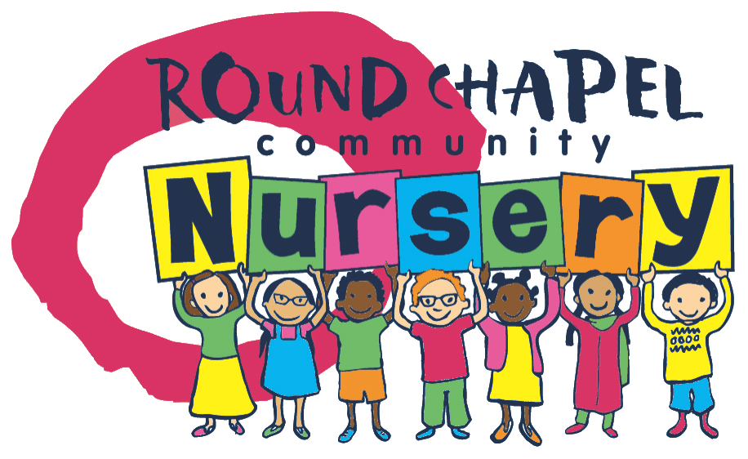
The Round Chapel Community Nursery
Clapton Park URC, Round Chapel Old School Rooms, 2 Powerscroft Road
E5 0PU
Tel. 02085337714
emma@theroundchapel.org.uk

Round Chapel Nursery Childcare Registration and Agreement Form
This form must be completed by someone who has parental responsibility. Please tick the sessions you would like.
Monday | Tuesday | Wednesday | Thursday | Friday
8.30-13.30 | 8.30-13.30 | 8.30-13.30 | 8.30-13.30 | 8.30-13.30
13.00-16.30 | 13.00-16.30 | 13.00-16.30 | 13.00-16.30

Child’s Full Name

Preferred or Familiar Name

Child’s Date of Birth

Child identification | Birth Certificate Medical Card Passport
Mother Full Name
NI
DOB
Contact Number

Address

Email Address
Work address and contact number

Father Full Name
NI
DOB
Contact Number

Address

Email Address
Work address and contact number

Carer Full Name
Contact Number

Address

Email Address
Work address and contact number

Who does the child live with?

Child’s Usual Address

Has your child got a Social Worker? If your child has a Social Worker could you please provide their full name and the local authority they work for?

Is your family working collectively with a Family Support Worker?

If your child has a Family Support Worker please provide details here

Emergency Contact Person 1
Please provide full name, address and telephone number

Emergency Contact Person 2
Please provide full name, address and telephone number

Emergency Contact Person 3
Please provide full name, address and telephone number

Legal Responsibility  E.g. the parent/carer who is your child’s main carer(s) | The following people can have PARENTAL RESPONSIBILITY for a child under 16  - The child’s mother  - The child’s father if he was married to the mother when the child was born  - Children born before 1st December 2003 – the child’s father if he marries the mother, obtains a parental responsibility order from the court or registers a parental responsibility agreement with the court  - For children born on or after 1st Decemb^{er} 2003 – the child’s father if he registered the child’s birth with the mother at the time of the birth or if he r-registers the birth (if he is the natural father) marries the mother and obtains a parental responsibility agreement with the court  - The child’s legally appointed guardian  - A person with a residence order concerning the child  - A local authority that is designated to care for the child
Who has legal contact with your child e.g. a parent who lives at a different address

Please provide their full name and address

Health Information

Doctor’s Name, Address and Telephone Number

Health Visitor’s Name and Telephone Number
Does your child have any special Health requirements?

Does your child have any known allergies?

Is your child up to date with all immunisations?

Consent Information  Outings  Holding personal information including your personal email  Sharing info & Health Visitor etc.  Photography to be used in-house e.g. photo observations  Newsletters, nursery’s information and updates  First Aid and Emergency Medical Treatment | Please mark your consent below
Other Information

Your child’s Ethnic Origin

Festivals Celebrated at Home

Details of any other settings or childcare attended

Details of any other agencies or professionals working with your child

Any other information that might be useful for us to know e.g. what your child likes, what their fears may be, any special words they use

Is anything about you (parent/carer) or your family such as a health condition that you would like to be supported with or us to know?

Please note that we require a month’s notice if you decide that your child will stop attending our nursery. | Please mark as read
Agreement | I agree to all the above condition
Parent / Carer Signature

Mother
Father

Date

